Spring boot provide another new module base upon JPA ie
Spring JPA data: Spring JPA data provided two pre defined interface is
CrudRepository
JpaRepository

We need to make normal interface and that interface must be extends JpaRepository. This interface base upon Java 8 features which provide us default implementation of our POJO or entity class
Entity class bind with table in database.
@Entity --- This annotation provided by JPA we can use in Hibernate /JPA
@Table(name=”productdetails”) if table name is different use table annotation to link entity class with table.
class Product {
@Id the column which link primary key
@Column(name=”pid”)
private int pid;
@Column(name=”productname”)
private String pname;
@Column(name=”price”)
private float price;
}

@Repository
class ProductDao{
we were/are writing code using hibernate or JPA to store, delete, update and retrieve entity class object rather than writing SQL query
}
Or
@Repository
interface ProductRepository extends JpaRepository<Product,Integer> {
spring jpa data internally provided all database logic implementation.
We can write custom method base upon our requirement.
}

Those method we need to call in service layer.

Creating spring boot project which help to create Rest API for product with database as mysql
Starter - web
Starter jpa
Dependencies mysql

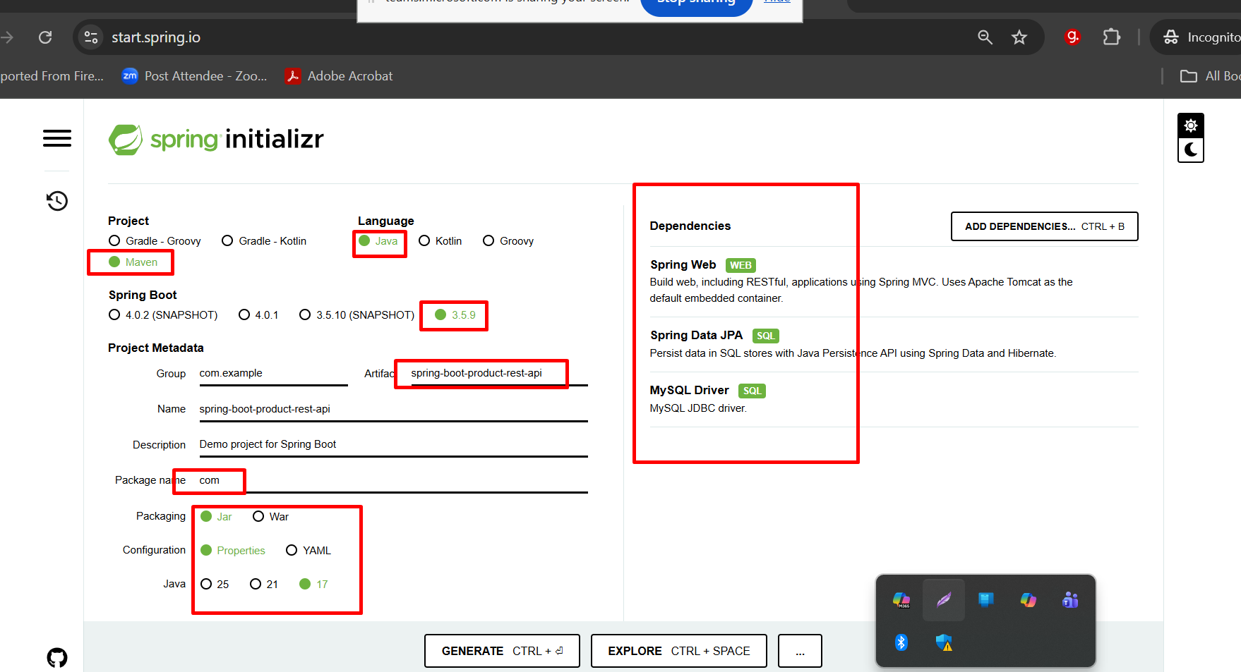

Get method : Retrieve all product details in json format
Search particular product information using pid,pname,price
We use two technique
- Using query param
URL?key=value
URL?key1=value1&key2=value2
- Using path param
URL/value1
URL/value1/value2

Testing post method through post man

